Individual Pathways
Activity 7.2

Investigating chemical reactions

- Which of the following processes is an example of a chemical reaction?
- An iron rusts in a damp environment.
- A mist forms when you breathe out onto cold glass.
- Ice melts as you hold it in the palm of your hand.
- A litre of water boils dry in a saucepan.

- How do the number and kinds of atoms involved as reactants in a chemical reaction compare to the number and kinds of atoms in the products?
- There are more atoms that react.
- There are more atoms that are produced.
- There are the same number and kind of each.
- It varies from one reaction to another.

- Which of these processes is always endothermic?
- Combustion
- Freezing
- Melting
- Condensation

- Which of the following temperature changes is not the result of a chemical change?
- A rise in temperature when a fuel burns
- A rise in temperature as neutralisation takes place
- A fall in temperature as a liquid metal cools to solidify
- A fall in temperature as ammonia is released when barium hydroxide is added to ammonium nitrate

- When vinegar is added to baking soda, bubbles of carbon dioxide rapidly form. A cloudy liquid is left behind. What are the products in this chemical reaction?
- Vinegar and the cloudy liquid
- Vinegar and baking soda
- Carbon dioxide and baking soda
- Carbon dioxide and the cloudy liquid

- Which of the following materials is the most acidic?
- Grapefruit juice of pH 3.0
- Detergent of pH 10.5
- Gastric juice of pH 1.0
- Sea water of pH 8.5

- Which list shows the four substances in order from the strongest acid to the strongest base?
- Sulfuric acid, acetic acid, pure water, cloudy ammonia, sodium hydroxide
- Acetic acid, sulfuric acid, pure water, sodium hydroxide, cloudy ammonia
- Pure water, sulfuric acid, cloudy ammonia, acetic acid, sodium hydroxide
- Sodium hydroxide, cloudy ammonia, pure water, acetic acid, sulfuric acid

- Which of the following solutions would be the most dangerous?
- Concentrated acid
- Diluted acid
- Neutral mixture of an acid and a base
- Solution with a pH of 7

- In chemical reactions, mass is neither gained nor lost. The total mass of all the reactants equals the total mass of all the products. Atoms are just rearranged into different substances. Use this information to complete the following questions.

  - Iron is oxidised by oxygen in the air, forming iron oxide.
How many grams of oxygen are needed to react with 350 g of iron to produce 500 g of iron oxide?
........................................................................
  - Combustion of methane in a gas heater produces carbon dioxide and water vapour.
If 16 g of methane reacts with 64 g of oxygen, producing 44 g of carbon dioxide, how many grams of water vapour are produced?
.......................................................................
- The apparatus below was used to neutralise basic solutions using acids.
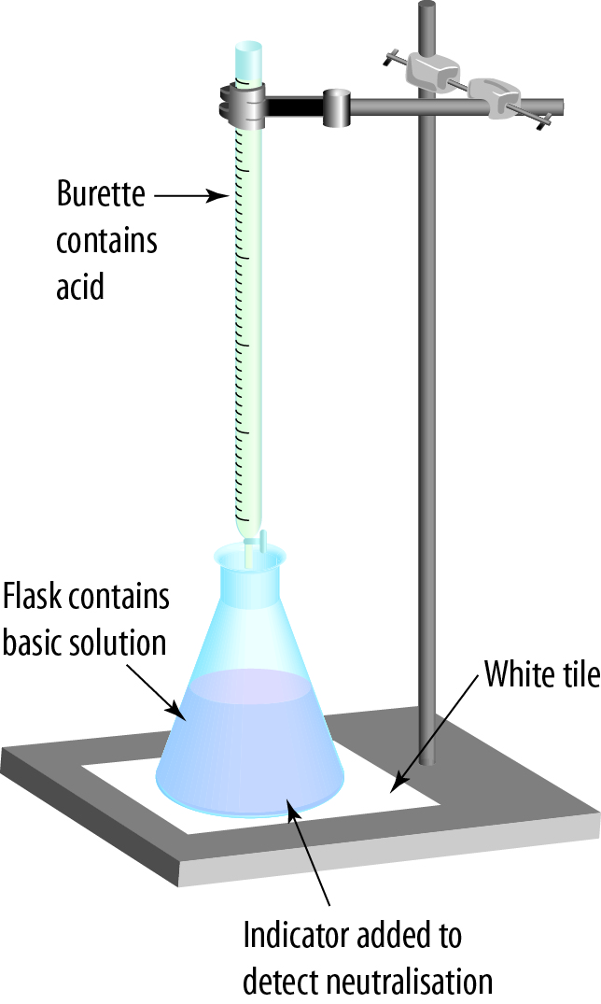

25 mL of potassium hydroxide (KOH) was added to the flask. Three drops of universal indicator were also added to the flask. Nitric acid (HNO₃) was then added from the burette into the flask until the indicator changed colour.
- What colour will this indicator become when added to the potassium hydroxide solution?
.................................................................................................................................................
- The acid is added in small amounts until the indicator just turns green. Identify the substances that are now present in the flask.
.................................................................................................................................................
- Write a word equation for this reaction.
.................................................................................................................................................

- Complete the matrix table below.
 | Exothermic  processes | Endothermic  processes
Energy is transformed
Energy is absorbed from surroundings
Energy is released from surroundings
Portable hand warmers
The surroundings get colder
Chemical explosions are examples
- Azaleas grow only in soil with a pH less than 7. Would you add water, an acid, or a base to basic soil to lower the soil pH? Explain your answer.
.............................................................................................................................................................
.............................................................................................................................................................

- Complete the following word equations:
- sodium carbonate + nitric acid → _____________________ + _________ + _______________
- potassium hydroxide + _____________________ → sodium sulfate + __________
- propane + ______________ → ____________________ + water
- magnesium + hydrochloric acid → _______________________ + _____________
- glucose + ______________ → __________________ + ____________
- Which of the reactions (a)–(e) represent respiration?

- Here are the pH values of some solutions.

Salt water | pH = 7.0
Stomach acid | pH = 1.0
Blood | pH = 7.4
Orange juice | pH = 3.4
Sea water | pH = 8.5
Rain water | pH = 5.6

  - Which is the most acidic substance?
- Which is the most basic substance?
- Which substance is neutral?
- Which substance could be used to neutralise rainwater?
- Which substance would react with sodium carbonate to produce carbon dioxide?

- Cross out the incorrect example in each of the following.
- The products of the reaction between an acid and a metal carbonate include:
hydrogen, a salt, carbon dioxide, water.
- Combustions reactions involve the production of:
carbon dioxide, energy, oxygen, water.
- Acid rain can cause problems such as:
acidic waterways, global warming, damage to statues, killing trees.

- Gases that cause acid rain include:
carbon dioxide, oxygen, nitrogen oxide, sulfur dioxide.
- Properties of bases include:
taste bitter, corrosive, low pH, feel soapy.
- Neutralisation reactions:
occur between an acid and a base, produce water and hydrogen, can be used to relieve indigestion, help plants grow.
- Chemical reactions in which energy is released:
are exothermic, cause a temperature decrease, include combustion, can be explosive.

